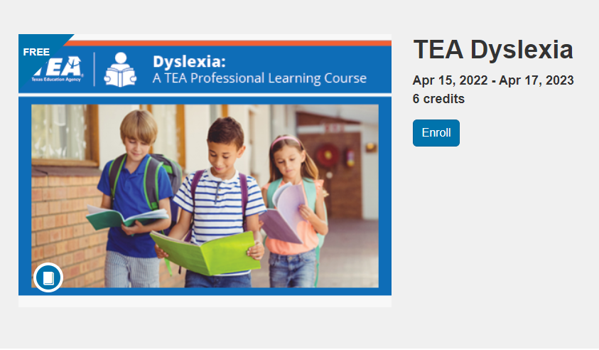

**TEALearn Dyslexia Online Course**

The TEALearn Dyslexia online course is available and provides 6 hours of continuing education in the area of dyslexia.

This course is designed for all school and district staff members who serve students in kindergarten through grade 12. The purpose is to empower educators to serve and advocate for students with or at-risk for dyslexia.

This course consists of 4 modules. Each module ends with a Check for Understanding.

Introduction  
Module 1: Understanding Dyslexia  
Module 2: Meeting the Needs of Students with Dyslexia at the Schoolwide Level  
Module 3: Meeting the Needs of Students with Dyslexia in the Classroom  
Module 4: Taking Action

<https://register.tealearn.com/browse/tea/dyslexia/courses/tea-dyslexia>